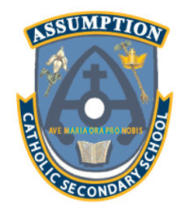
Fitness and Sport Leadership
SHSM Application

Student Information

Name: | Student Number: | Grade:
# of credits earned to date: | Home phone Number: | Date of birth (Y/M/D)
Course Planning:
Please see reverse side for courses.
Depending on your current grade, you may circle courses already completed, currently in your timetable OR courses you plan to take.

Please return this form to the guidance department when completed.

Circle your probable pathway:

University College Apprenticeship Workplace

For CO-OP placement purposes
Preference for a placement in a specific job/career or with a specific employer? | Choice 1: | Choice 2:
Circle your preferred grade for your co-op program | Grade 11 | Grade 12
Circle your preferred schedule for your co-op program | Summer school | Semester 1/semester 2

You will be interviewed by a coop teacher to determine placement options
Bottom section for office use only
Counsellor’s Notes:

Student Signature: Date:
Parent/Guardian Signature: Date:

For Additional information please visit:
http://www.gobluego.ca/linked/shsm_fitness_leadership_assumption_2015.pdf
WHAT IS SHSM?  Every SHSM must include the following 5 components:  - A specific bundle of 9 credits including contextualized learning activities (CLA’s)  - Sector-recognized certifications and/or training courses  - Experiential learning activities within the sector  - Reach ahead: experiences connected with the student’s chosen post secondary pathway  - Development of key essential skills and work habits required in the sector and the use of the Ontario skills passport for purposes of documentation  What is meant by bundles credits?  The bundle of 9 credits in grades 11 and 12 must include:  - 4 major credits that provide sector-specific knowledge and skills  - 3 “other” required credits from the Ontario curriculum, in which some expectations are met through learning activities contextualized to the sector (CLA’s)  - Minimum of 2 credits in cooperative education related to the major credits |  |  | Ministry requirements # of credits required (Minimum 9) |  | Assumption  SHSM  Courses
 |  |  |  |  | Grade 11 | Grade 12
 |  | Major subjects | 4 | Circle at least one in grade 11 and one in grade 12. | PPL3O  PAI3OR  PAF3O  PAL30  SBI3C  SBI3U  SCH3U  HSP3  HPC30  BMI3C | PPL40  PAF40  PAI40R  PSE4U1  IDU4U  SBI4U  SCH4U  BOH4M
 |  | English | 1 | Circle one in grade 12 |  | ENG4U  ENG4C  ENG4E
 |  | Math | Minimum 1 | Circle one in grade 11 | MBF3C  MCF3M  MCR3U  MEL3E
 |  | Science or Social science & Humanities | Minimum 1 | Circle one option in grade 11 OR grade 12 | BDI3C  BMI3C1  HPC301  SBI3C  SBI3U  HSP3C  SCH3U  SPH3U | BOH4M  TGJ4M  CLN4U  SBI4U  SCH4C  SCH4U  SPH4U  HSB4U
 |  | Co-operative education | Minimum 2  **if a student takes 3 credit coop, one credit may be used as a major | Circle one option in grade 11 OR grade 12 OR coop can be completed in summer school | 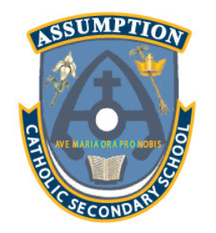  COOP 2 Credit | COOP 2 credit

