AGENDA -ASSUMPTION CATHOLIC SCHOOL COUNCIL MEETING Via Teams Video Conference Tuesday, December 8th, 2021 @ 6:00pm

1. Call to order-with opening prayer- Clark McDougall - 2 minutes
2. Roll call-1 minute
3. Approval of Agenda-1 minute
4. Approval of minutes from November 9th, 2021-1 minute
5. Business Arising from Previous Meeting- Updates - 5 minutes
6. Student Report-student council representative- Mia Rodgers-5 minutes
7. Teacher’s Report - Mario Soster & Miranda Walsh - 10 minutes
8. Treasurer’s Report - Pascale Lapointe-Antunes - 5 minutes
9. Fundraising Committee Update – 3 minutes
10. Uniform Committee Update – 3 minutes
11. Mental Health Speaker Series Committee Update – 3 minutes
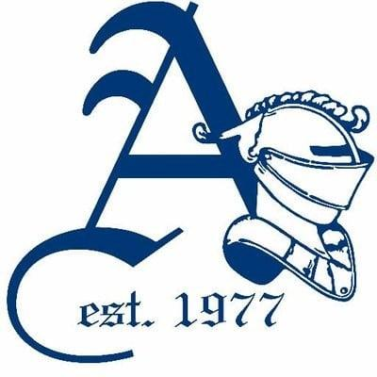
12. Principal’s Report-Clark McDougall-10 minutes
13. Chaplain’s Report-Andrea Taylor-5 minutes
14. Parish Update-Gabriella Starcevic - 5 minutes
15. OAPCE Report- Maria Lourenco-5 minutes
16. New Business-5 minutes
- Sanitary Product Accessibility
17. Closing Prayer and Adjournment-2 minutes (Clark McDougall)

NEXT MEETING- Feb. 9th, 2021 @ 7:00pm

