AGENDA -ASSUMPTION CATHOLIC SCHOOL COUNCIL MEETING Via Teams Video Conference Wednesday, February 9th, 2022 @ 7:00pm

- Opening prayer - Adriana Rerecich
- Land acknowledgment - Adriana Rerecich
- Roll call-1 minute
- Approval of Agenda-1 minute
- Approval of minutes from December 8th - 1 minute
- Business Arising from Previous Meeting- Updates - 5 minutes
- Student Report - student council representative - Mia Rodgers-5 minutes
- Teacher’s Report - Mario Soster, Miranda Walsh, Evonne Quintal - 10 minutes
- Treasurer’s Report - Pascale Lapointe-Antunes - 5 minutes
- Fundraising Committee Update – 15 minutes – Briana Hamlet
- Uniform Committee Update – 5 minutes
- Mental Health Speaker Series Update – 3 minutes – Belinda Bastos
- Aesthetics Committee Update – 5 minutes
- Principal’s Report - Clark McDougall - 10 minutes
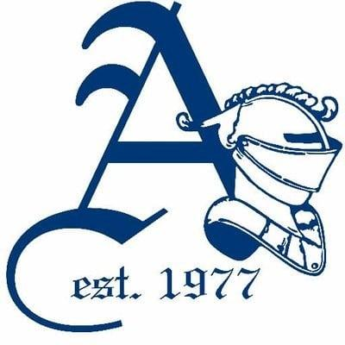
- Chaplain’s Report-Adriana Rerecich - 5 minutes
- Parish Update - Gabriella Starcevic - 5 minutes
- OAPCE Report - Maria Lourenco - 5 minutes
- New Business
- Closing Prayer - Adriana Rerecich

NEXT MEETING- Wednesday, April 6th, 2022 @ 6:00pm

