How to Steps to pay the Student Activity Fee

Corpus Christi 2022/2023 Student Activity Fee - $65
Use the link below to pay your Student Activity Fee (SAF). This link will take you to the School Cash Online website.
If you do not already have a School Cash Online account, please create one now.

- Link: https://hcdsb.schoolcashonline.com/Fee/Details/47159/6/False/True

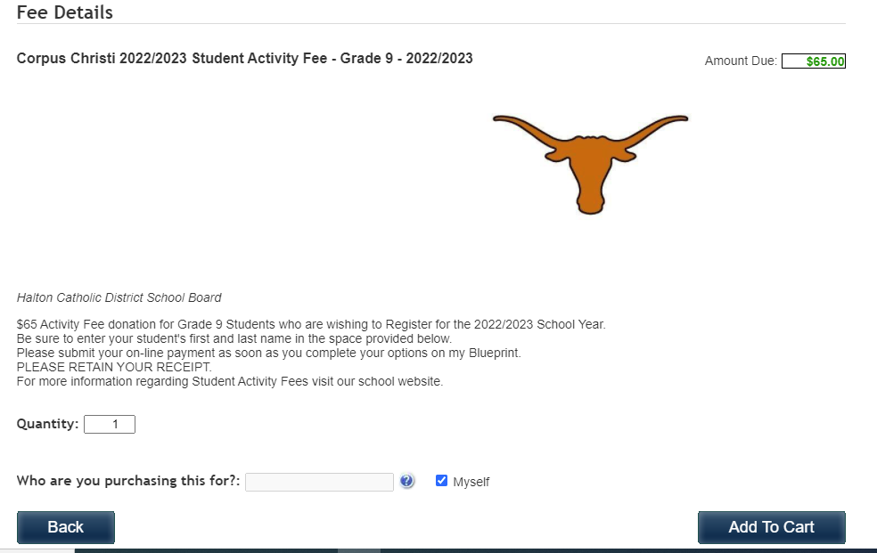
- The link above will bring you to this page
- Who are you purchasing this for? TYPE YOUR STUDENTS FULL NAME (FIRST/LAST)
- CLICK TO REMOVE THE CHECKMARK – MYSELF – LEAVE BOX UNCHECKED
- Once you click Add to Cart, you will be taken to this page.
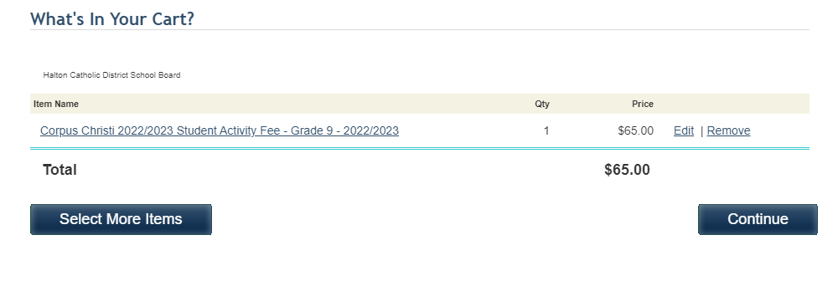
- After checking the information is correct, click continue and follow the prompts until you finish the order and have an order confirmation. PLEASE PRINT/RETAIN YOUR RECEIPT.

