How to register for School Cash Online
STEP 1:
Navigate to the URL for your School Board’s School Cash Online site. https://hcdsb.schoolcashonline.com/ or many of our schools have a link on their homepage.
Click the Register option.
You will be redirected to the User Registration page
Fill in the User Registration form.
Tip: Your password must contain at least 8 characters and must consist of one upper case letter, one lower case letter, and one number.
Note: A red x indicates that there is an error with the information entered. Edit all fields that do not have a blue and white check mark on the right-hand side.
Select Continue.
You will be redirected to the Confirmation Email page.
STEP 2:
Check your email inbox for an email from noReply@schoolcashonline.com.
Click on the Registration Confirmation link.
A new tab will open advising you that your registration was successful.
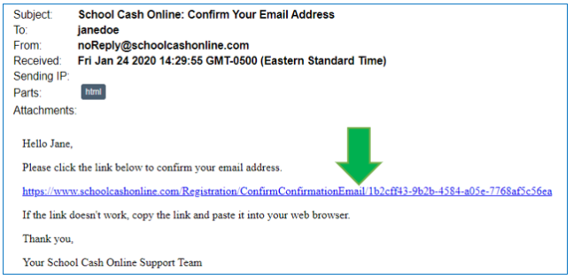
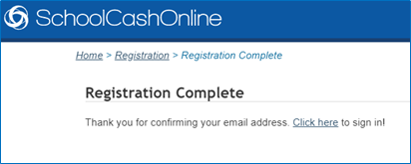

Step 3:
Go to School Cash Online’s support page for additional assistance with adding students as well as any other questions you may have.
https://helpdesk.supportschoolcashonline.com/en/support/home?email=&board_name=Halton%20Catholic%20District%20School%20Board&mw=1&mp=0
