CtK Arts and Culture SHSM Planner 2024-2025

Arts and Culture Specialist High Skills Major  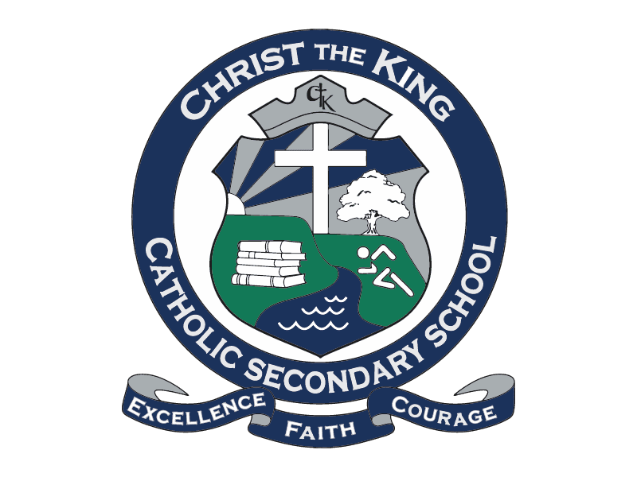  4 major credits are required | Grade 11 | Grade 12
 | Arts (1 Credit Mandatory)  - AMT3M 1 credit Music Theatre  - AMU3M Music Instrumental  - AMR3M Music Repertoire (NEW)  - AMV3M Music Vocals  - AMG3M Guitar  - ATC3M Dance  - ATD3M Dance Choreography  - ADA3M Drama  - AMM3M Music and Computers  Social Sciences  - HNC3C Fashion  (Select at least one for grade 11) | Arts (1 Credit Mandatory)  - AMT4M 1 credit Music Theatre  - AMU4M Music Instrumental  - AMR4M Music Repertoire (NEW)  - AMV4M Music Vocals  - AMG4M Guitar  - ATC4M Dance  - ATD4M Dance Choreography  - ADA4M Drama  Social Sciences  - HNB4M Fashion  (Select at least one for grade 12)
Other Compulsory Course  Social Science, Canadian and World Studies or Business  (Select one course from either gr. 11 or gr. 12)  (You can substitute this choice with a 3rd co-op credit or a dual credit) | Business  - BDI3C Entrepreneurship  - BMI3C Marketing  - BAF3M Accounting  Canadian and World Studies  - CLU3M Canadian Law  - CHA3U American History  - CHW3M Ancient History  - CHT3O World History  - CGG3O Travel and Tourism | Business  - BBB4M International Business  - BBB4E Business Essentials  - BAT4M Accounting  - BOH4M Business Leadership  Canadian and World Studies  - CLN4C/U Canadian Law  - CHY4C/U World History  - CPW4U Politics  Social Science  - HSB4U Challenge & Change

Other Mandatory Courses  (Select one option from each of the three categories listed: Math, English & Co-op)  NOTE: Gr. 11 Math is NOT required for this SHSM program, but it is required for graduation | Math  - MCR3U Functions  - MCF3M Functions & Applications  - MBF3C Foundations for College  - MEL3E Math for Work  English  - ENG3U English – University  - NBE3U English – Indigenous Focus  - ENG3C English - College  - ENG3E English – Workplace | Internship Experience (Co-op)  (Select one option in either gr. 11, gr. 12 or summer)  - NGC4O1 Co-op (2 credit day)  - NGC4O3 Co-op (3 Credit OYAP)  (For the next two options, you need to choose both or the same choice twice)  - NGC4O1 Co-op (1 credit Night)  - NGC4O1 Co-op (1 credit Summer)

