CtK ICT SHSM Planner 2024-2025

Information and Communication Technology Specialist High Skills Major  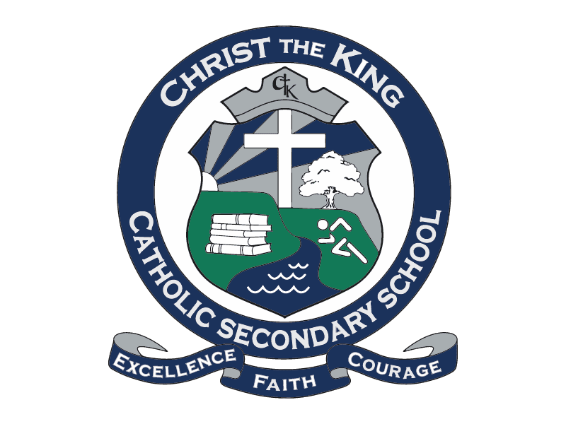  4 major credits are required | Grade 11 | Grade 12
 | Technology (1 Credit Mandatory)  - TDJ3M 1 credit Tech Design  - TGJ3M 1 credit Comm Tech  - TGG3MY Yearbook/Graphic Design  - TEJ3M Computer Engineering  - TCJ3C Construction  Computers  - ICS3C/U Computer Programming  Guidance  - IDC3O E-Sports (NEW)  Music  - AMM3M Music & Computers  (Select at least one for grade 11) | Technology (1 Credit Mandatory)  - TDJ4M 1 Credit Tech Design  - TGJ4M 1 credit Comm Tech  - TGG4M Yearbook/Graphic Design  - TGP4M Photography  - TEJ4M Computer Engineering  - TCJ4C Construction  Computers  - ICS4C/U Computer Programming  Guidance  - IDC4UL Leadership  (Select at least one for grade 12)
Other Compulsory Course  Social Science, Science or Business  (Select one course from either gr. 11 or gr. 12)  (You can substitute this choice with a 3rd co-op credit or a dual credit) | Business  - BDI3C Entrepreneurship  - BMI3C Marketing  - BAF3M Accounting  - CIE3M Economics  Science  - SBI3C/U Biology  - SCH3U Chemistry  - SPH3U Physics  Canadian and World Studies  - CLU3M Canadian Law  Arts  - AVI3M Visual Arts | Business  - BBB4M International Business  - BBB4E Business Essentials  - BOH4M Business Leadership  - CIA4U Economics  Science  - SBI4U Biology  - SCH4C/U Chemistry  - SPH4C/U Physics  Canadian and World Studies  - CLN4C/U Canadian Law

Other Mandatory Courses  (Select one option from each of the three categories listed: Math, English & Co-op) | Math  - MCR3U Functions  - MCF3M Functions & Applications  - MBF3C Foundations for College  - MEL3E Math for Work  English  - ENG3U English – University  - NBE3U English – Indigenous Focus  - ENG3C English - College  - ENG3E English – Workplace | Internship Experience (Co-op)  (Select one option in either gr. 11, gr. 12 or summer)  - NGC4O1 Co-op (2 credit day)  - NGC4O3 Co-op (3 Credit OYAP)  (For the next two options, you need to choose both or the same choice twice)  - NGC4O1 Co-op (1 credit Night)  - NGC4O1 Co-op (1 credit Summer)

