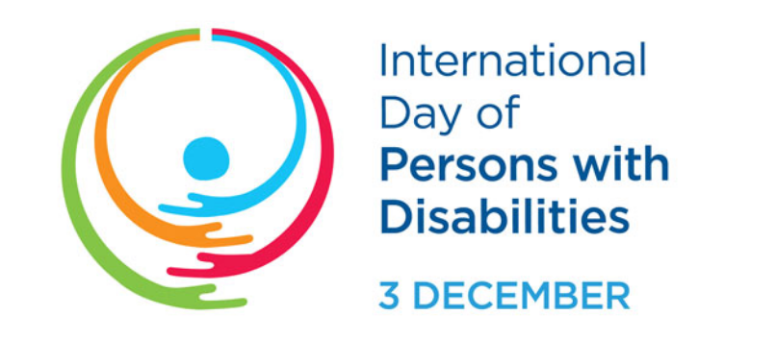
International Day of People with Disabilities takes place each year on December 3rd and Halton Catholic schools are recognizing this day. This day is set aside to increase knowledge and understanding about disabilities. HCDSB will recognize International Day of People with Disabilities with activities throughout the week of November 27th to December 1st.

This year, the theme from the United Nations is “United in action to rescue and achieve the Sustainable
Development Goals (SDGs) for, with and by persons with disabilities.” The SDG focus for HCDSB is “people.”

For more information about the International Day of People with Disabilities, please use the following link: https://www.un.org/en/observances/day-of-persons-with-disabilities

Women and girls with disabilities are acutely vulnerable to being left behind due to the intersection of
gender and disability, which compounds the challenges and barriers they encounter. An intersectional lens is crucial for fulfilling the pledge that no one will be left behind. Use the following link to access an article on women and girls with disabilities:
https://hcdsborg.sharepoint.com/sites/FormsMemos/Memos%20List/Forms/Current%20Memos%20n%20Attachements.aspx?id=%2Fsites%2FFormsMemos%2FMemos%20List%2FMaking%20SDGs%20count%20for%20women%20with%20disabilities%2Epdf&parent=%2Fsites%2FFormsMemos%2FMemos%20List

Other articles that may be of interest include:
https://www.webmd.com/add-adhd/features/what-is-neurodiversity
https://hbr.org/2017/05/neurodiversity-as-a-competitive-advantage

