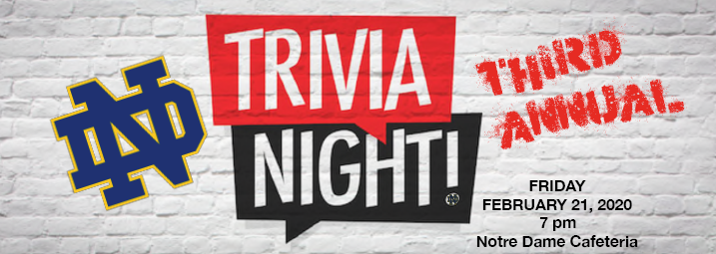
NOTRE DAME TRIVIA NIGHT REGISTRATION FORM
February 21, 2020
6:00pm Doors Open
6:30pm Silent Auction begins
7:00pm Trivia begins

Prizes, Prizes, Prizes! Round One, Two and Three and the TRIVIA MASTER OVER ALL TOTAL! Best Team Costumes,
Best Team Name and Most Spirited

Snacks Refreshments will be provided by the Nutrition Department students. Pizza will be ordered and for sale.

Cost $100.00 per team/table up to 10 people per team (14 yrs. and up!)
$10.00 single player

No electronic devices allowed!

Please fill in and email to robinsonb@hcdsb.org.

TEAM NAME ___________

CONTACT PERSON _________________

CONTACT PERSON PHONE____________

CONTACT PERSON E-MAIL ____________

HOW WILL YOU BE PAYING YOUR FEE? Note YES beside your choice.
____ Cheque (made payable to Notre Dame Catholic Secondary School)
____ Cash online
____ Cash or Cheque night of event

See you on February 21st! Thank you for your support!

