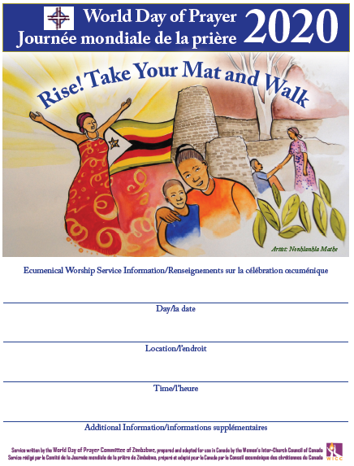

**THE CHURCH IS LOCATED ACROSS FROM**

**SHERIDAN COLLEGE TEL. #905-845-8351**

**7PM**

***(PLEASE NOTE THIS IS AN EVENING SERVICE)***

**ST. SIMON’S ANGLICANCHURCH**

**1450 LITCHFIELD ROAD, OAKVILLE**

**FRIDAY EVENING MARCH 6th, 2020 @ 7PM**