B | I | N | G | O
Got enough sleep  last night | Enjoyed guilt-free alone time / set up boundaries with family | Cooked a new meal recipe with my spouse and/or children | Made time for reading (an article, a blog,  a book…) | Listened to  a cool podcast
Wore an outfit I love | Challenged negative thoughts, replaced with positive thoughts | Drank water! | Turned off all screens and devices 2 hours before bedtime | Video-chatted  with a friend
Worked out / used  the exercise equipment  in the house | Used a new  coping skill / strategy | 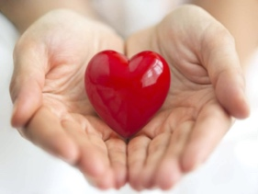 | (Christian)  meditation | Watched a “how-to” YouTube video and learned something new
Went for a 30 minute walk/spent time in nature | Treated myself (did my nails, a facial, bought a favourite snack…) | Ate healthy  snacks today | Made a  gratitude list | Checked in on an elderly family member / friend
Danced! | Sat with my feelings,  able to name them | Did not eat  after 8 p.m. | Practiced  self-compassion | Watched my  favourite movie
Planted a garden | Cuddled with my pet | Made a cup of tea | Laughed | Gave my family members positive affirmations / compliments

