Wellington-Halton District Women’s Institute
Dr. Ethel Chapman - Historical Background

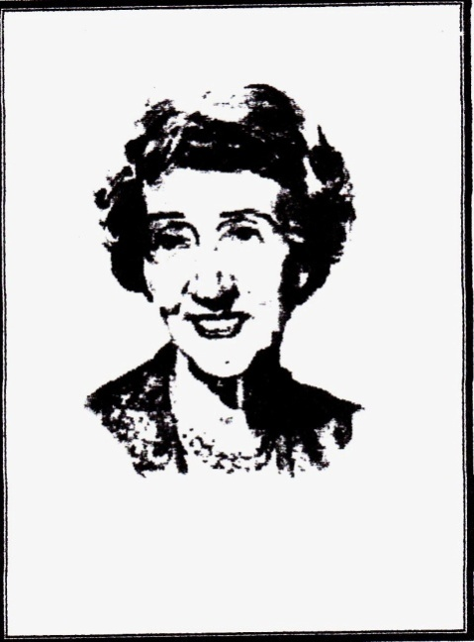
Dr. Ethel Chapman

Dr. Ethel Chapman was born in 1888 to a Halton County farm family near Campbellville, just five miles from the rural public school where she would begin her teaching career. The building is now in a place of honour in the County Heritage Park, Milton, as an example of a Women’s Institute Hall.
No one, on the day of her birth, could have predicted that in her long lifetime, she would become a teacher, a government home economist, Editor of the Federated Women’s Institute of Ontario quarterly magazine, “Home & Country”, author of five novels and numerous papers and that among many other honours, she would become an inductee into the Ontario Agricultural Hall of Fame. As a role model to generations of girls and young women throughout the province, she stressed the importance of education that would prepare them for future careers.
In 1966, in one of its first convocations with full university status, the University of Guelph conferred upon Ethel Chapman the Honorary Degree of Doctor of Laws. Dr. Chapman was loved and respected as a leader, a mentor and a friend.

Wellington-Halton District Women’s Institute
Dr. Ethel Chapman Scholarship
Application Form

Value $1,000.00
- A student must reside in the City of Guelph, or the Townships of Centre Wellington, Mapleton, Guelph/Eramosa, Erin, Puslinch or the Region of Halton.
- A student graduating this year or did graduate last year from a secondary school program and continuing their education.
- A student may win only once.
- A student must show personal growth, leadership and community involvement.
- Recommendation from a community leader or past or present employer.
- In your own words ( 350 - 400 words) please explain
“What winning the Dr. Ethel Chapman Scholarship would mean to me”
- In a few lines (50-75 words) tell, what you know about The Women’s Institute. What’s the nearest Women’s Institute Branch to where you live?
- Proof of attendance must be provided in the fall before the money is awarded.
- If any successful scholarship recipient does not attend post secondary school in the fall or spring for any reason, he/she will forfeit the scholarship to allow another student to take advantage of the program.
Applicants must be received by March 31 by email or postage
Wellington –Halton District Women’s Institute
c/o: Mrs. Doris Calder P.O. Box 135 Hillsburgh, ON. N0B 1Z0
Or
Email completed forms in JPG, PDF or WORD FILE signed with attachments to address below.
wellingtonhaltonwomensinstitute@yahoo.ca
For Info or questions phone Doris Calder: 519-855-6562 or 416- 571- 6476

Dr. Ethel Chapman Scholarship

Application Form

Applicant’s Name: ________________________________________________________
(print)

Applicant’s Address: _______________________________________________________
(street)
_______________________________________________________
(City/town) (Postal Code)

Email: ___________________________ Phone: ________________________

Birth Date: ______________________________________________________________

Name of Parent/Guardian: __________________________________________________

Name of School: __________________________________________________________

Academic standing (percentage) at most recent semester: ________________________

Signature of Principal, Vice-Principal or Guidance Counselor:

______________________

Wellington-Halton District Women’s Institute
Dr. Ethel Chapman Scholarship
Application Form

Attach to this application:

- List in point form under the following headings your involvement in: a) Extra Curricular Activities, b) Community Activities and c) Leadership Roles.
- Your plans for further education for which you intend to use this award.
- 350-500 word essay – topic: “What winning the Dr. Ethel Chapman Scholarship would mean to me”.
- In a few lines (50-75 words) tell, what you know about The Women’s Institute.
- What’s the nearest Women’s Institute Branch to where you live?
- Letter of recommendation from a community leader or past or present employer.

Applicant’s Signature: ______________________________________________________

Date: _______________________________________

Note: This application must include the signature of one of the following: Principal, Vice Principal or Guidance Counselor, and must include all accompanying documents and must be received on or before the deadline date of March 31st

