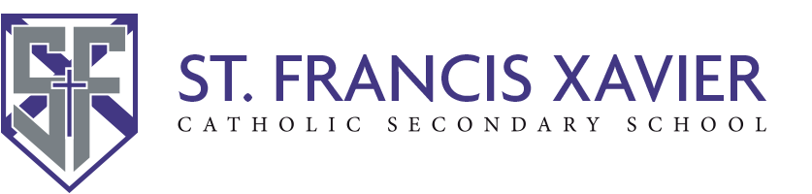

FOR STUDENTS ONLY
Confirmation of Daily COVID-19 Screening
Effective Monday, February 8, secondary school STUDENTS attending in-person learning will need to provide confirmation that they have completed the self-screening and received a ‘PASS to attend school. Any STUDENT who does not pass the School Screening Tool must stay home and self-isolate until they meet the criteria for return.
STUDENTS should complete the self-assessment question using the QR Code or the link below each time they attend school in-person. A verification email is then sent to the student’s HCDSB email account.
DAILY COVID SELF-ASSESSMENT
- STUDENTS will be required to show their classroom teacher the ‘PASS’ confirmation on their personal device (e.g., phone, laptop, etc.) or show a printed copy of the ‘PASS” confirmation.
- STUDENTS unable to provide such confirmation to their teacher will be directed to the office where assistance will be provided.
- STUDENTS with special education needs who require assistance will be contacted by their teachers to make arrangements for alternate ways to confirm that they have completed the screening (e.g., setting up electronic practice, verbal communication, provision of paper copies of the screening tool)

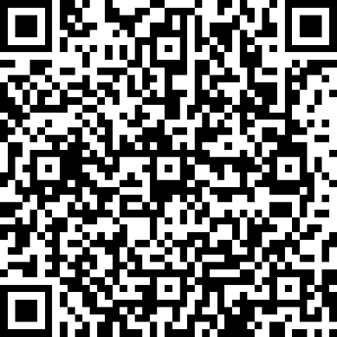

Use QR code using your camera app or type in the link here (case-sensitive):

https://bit.ly/3rpMfM7

