St. Francis Xavier Catholic Secondary School
Daily Schedule

Warning Bell: 8:15
Morning Prayer and Announcements: 8:20-8:25
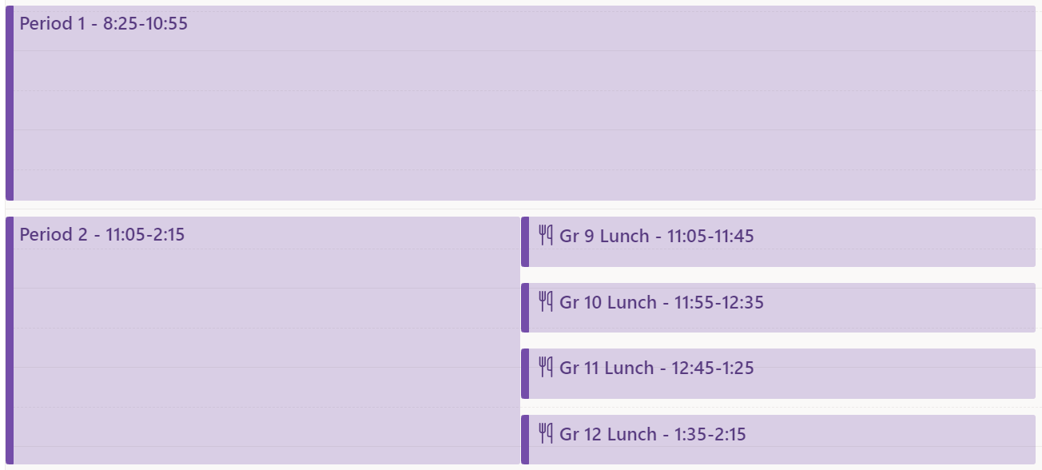
Staggered Dismissal: 2:15-2:20

Grade 9 Period 2
Lunch: 11:05-11:45
In-class: 11:45-2:15

Grade 10 Period 2
In-class: 11:05-11:55
Lunch: 11:55-12:35
In-class: 12:35-2:15

Grade 11 Period 2
In-class: 11:05-12:45
Lunch: 12:45-1:25
In-class: 1:25-2:15

Grade 12 Period 2
In-class: 11:05-1:35
Lunch: 1:35-2:15

